AI Assignment-11

Jeetu Mehra
U24AI032

Question 1 : 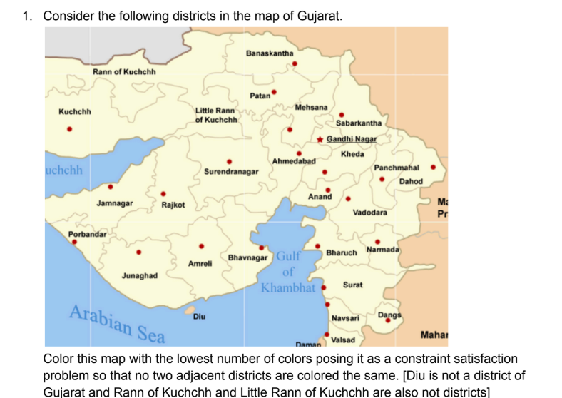
Code:

graph = {
"Kutch": ["Banaskantha", "Surendranagar", "Jamnagar"],
"Banaskantha": ["Kutch", "Patan", "Sabarkantha"],
"Patan": ["Banaskantha", "Mehsana", "Surendranagar"],
"Mehsana": ["Patan", "Gandhinagar", "Sabarkantha"],
"Sabarkantha": ["Banaskantha", "Mehsana", "Gandhinagar", "Panchmahal"],
"Gandhinagar": ["Mehsana", "Ahmedabad", "Kheda", "Sabarkantha"],
"Ahmedabad": ["Gandhinagar", "Kheda", "Anand", "Surendranagar"],
"Kheda": ["Gandhinagar", "Ahmedabad", "Anand", "Panchmahal"],
"Anand": ["Ahmedabad", "Kheda", "Vadodara"],
"Vadodara": ["Anand", "Panchmahal", "Bharuch", "Narmada"],
"Panchmahal": ["Sabarkantha", "Kheda", "Vadodara", "Dahod"],
"Dahod": ["Panchmahal"],
"Surendranagar": ["Kutch", "Patan", "Ahmedabad", "Rajkot", "Bhavnagar"],
"Rajkot": ["Surendranagar", "Jamnagar", "Junagadh", "Amreli"],
"Jamnagar": ["Kutch", "Rajkot"],
"Junagadh": ["Rajkot", "Amreli"],
"Amreli": ["Rajkot", "Junagadh", "Bhavnagar"],
"Bhavnagar": ["Surendranagar", "Amreli"],
"Bharuch": ["Vadodara", "Surat", "Narmada"],
"Surat": ["Bharuch", "Navsari"],
"Navsari": ["Surat", "Valsad", "Dangs"],
"Valsad": ["Navsari"],
"Narmada": ["Vadodara", "Bharuch", "Dangs"],
"Dangs": ["Navsari", "Narmada"]
}

# Check if assignment is valid
def is_valid(node, color, assignment):
for neighbor in graph[node]:
if neighbor in assignment and assignment[neighbor] == color:
return False
return True

# Backtracking function
def backtrack(assignment, colors):
if len(assignment) == len(graph):
return assignment

# Select unassigned node
for node in graph:
if node not in assignment:
break

for color in colors:
if is_valid(node, color, assignment):
assignment[node] = color
result = backtrack(assignment, colors)
if result:
return result
del assignment[node]

return None

# Try with increasing number of colors
def solve_min_colors():
color_list = ["Red", "Green", "Blue", "Yellow"]

for k in range(1, 5): # Try 1 to 4 colors
colors = color_list[:k]
solution = backtrack({}, colors)

if solution:
print(f"\n✅ Minimum colors required: {k}\n")
for district in solution:
print(district, "->", solution[district])
return

print("No solution found!")

# Run
solve_min_colors()

Question 2 :
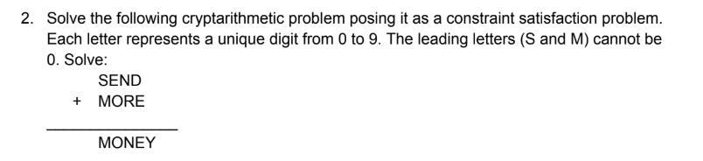

Code:
import itertools

letters = ('S','E','N','D','M','O','R','Y')
digits = range(10)

for perm in itertools.permutations(digits, len(letters)):
S,E,N,D,M,O,R,Y = perm

# Leading digit constraint
if S == 0 or M == 0:
continue

send = 1000*S + 100*E + 10*N + D
more = 1000*M + 100*O + 10*R + E
money = 10000*M + 1000*O + 100*N + 10*E + Y

if send + more == money:
print("Solution Found:")
print(f"S={S}, E={E}, N={N}, D={D}, M={M}, O={O}, R={R}, Y={Y}")
print(f"{send} + {more} = {money}")
break

